DC/DC电源模块 2-3W, 超高绝缘
MIW1000 / MIW1200系列

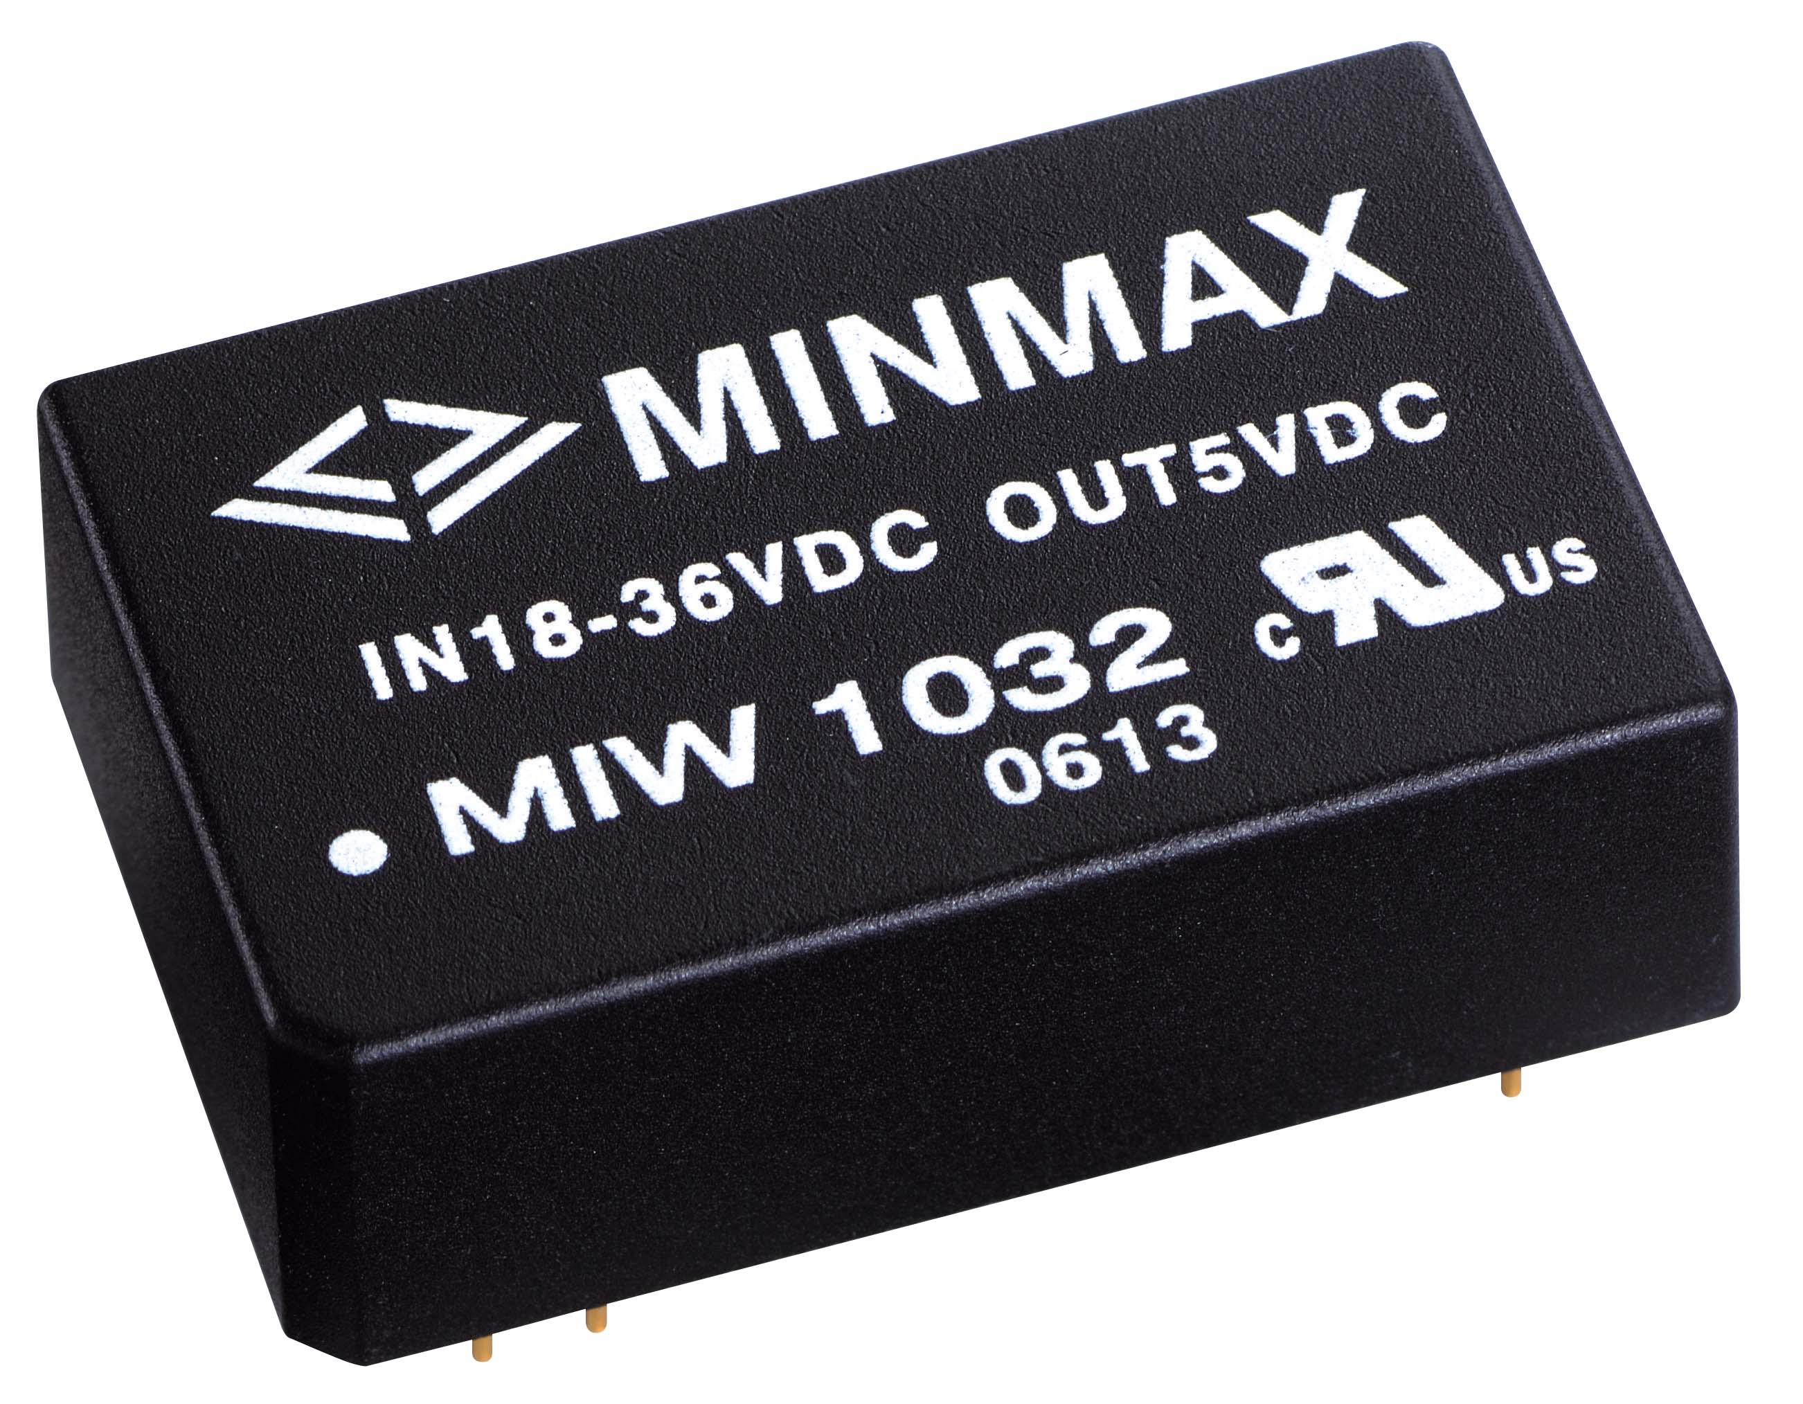 |  | 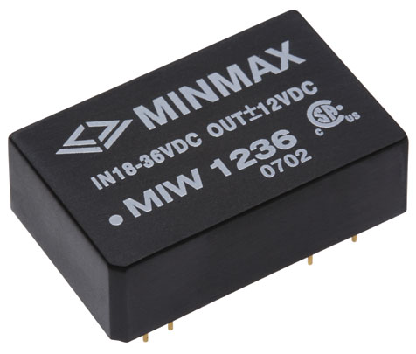 |  | 产品型号 |  | 输入电压 | 输出电压 | 输出电流
 |  |  |  | 特点
 |  |  |  | Low Cost | EMI Class A | VDC | VDC | mA Max.
 |  |  |  | MIW1011 |  | 5 ( 4.5 – 9 ) | 3.3 | 600
 |  |  |  | MIW1012 |  | 5 ( 4.5 – 9 ) | 5 | 500
 |  |  |  | MIW1013 |  | 5 ( 4.5 – 9 ) | 12 | 250
 |  |  |  | MIW1014 |  | 5 ( 4.5 – 9 ) | 15 | 200
 |  |  |  | MIW1015 |  | 5 ( 4.5 – 9 ) | ±5 | ±250
 |  |  |  | MIW1016 |  | 5 ( 4.5 – 9 ) | ±12 | ±125
 |  |  |  | MIW1017 |  | 5 ( 4.5 – 9 ) | ±15 | ±100
产品特性 |  |  |  | MIW1021 | MIW1221 | 12 ( 9 – 18 ) | 3.3 | 600
产品特性 |  |  |  | MIW1022 | MIW1222 | 12 ( 9 – 18 ) | 5 | 500
 |  |  |  | MIW1023 | MIW1223 | 12 ( 9 – 18 ) | 12 | 250
• 输出电压准确度 | ±0.5%典型值 |  |  | MIW1024 | MIW1224 | 12 ( 9 – 18 ) | 15 | 200
• 电压调整率 | ±0.2%典型值 |  |  | MIW1025 | MIW1225 | 12 ( 9 – 18 ) | ±5 | ±250
• 负载调整率 | ±0.2%典型值 |  |  | MIW1026 | MIW1226 | 12 ( 9 – 18 ) | ±12 | ±125
• 涟波杂讯 | 60mV P-P max |  |  | MIW1027 | MIW1227 | 12 ( 9 – 18 ) | ±15 | ±100
• 短路保护模式 | 连续性 |  |  | MIW1031 | MIW1231 | 24  ( 18 – 36 ) | 3.3 | 600
• 隔离电压 | 1.5kVDC |  |  | MIW1032 | MIW1232 | 24  ( 18 – 36 ) | 5 | 500
• 效率 | 高达86% |  |  | MIW1033 | MIW1233 | 24  ( 18 – 36 ) | 12 | 250
• 切换频率 | 300kHz 典型值 |  |  | MIW1034 | MIW1234 | 24  ( 18 – 36 ) | 15 | 200
• 工作温度 | MIW1000 – -40°C to +71°C |  |  | MIW1035 | MIW1235 | 24  ( 18 – 36 ) | ±5 | ±250
 | MIW1200 – -25°C to +71°C |  |  | MIW1036 | MIW1236 | 24  ( 18 – 36 ) | ±12 | ±125
• 外壳材质 | 塑胶, 94V-0 |  |  | MIW1037 | MIW1237 | 24  ( 18 – 36 ) | ±15 | ±100
• 平均故障使用时间 | 1 MHours min |  |  | MIW1041 | MIW1241 | 48  ( 36 – 72 )  ( 36 – 75 ) | 3.3 | 600
• 安全认证 | UL & CSA |  |  | MIW1042 | MIW1242 | 48  ( 36 – 72 )  ( 36 – 75 ) | 5 | 500
 |  |  |  | MIW1043 | MIW1243 | 48  ( 36 – 72 )  ( 36 – 75 ) | 12 | 250
 |  |  |  | MIW1044 | MIW1244 | 48  ( 36 – 72 )  ( 36 – 75 ) | 15 | 200
 |  |  |  | MIW1045 | MIW1245 | 48  ( 36 – 72 )  ( 36 – 75 ) | ±5 | ±250
 |  |  |  | MIW1046 | MIW1246 | 48  ( 36 – 72 )  ( 36 – 75 ) | ±12 | ±125
 |  |  |  | MIW1047 | MIW1247 | 48  ( 36 – 72 )  ( 36 – 75 ) | ±15 | ±100

MIW1000系列 |  |  |  |  |  |  |  | MIW1200系列
 |  |  |  | Pin | Single |  |  |  | Dual
 |  |  |  | 2, 3 | -Vin |  |  |  | -Vin
 |  |  |  | 9 | No Pin |  |  |  | Common
 |  |  |  | 11 | NC |  |  |  | -Vout
 |  |  |  | 14 | +Vout |  |  |  | +Vout
 |  |  |  | 16 | -Vout |  |  |  | Common
 |  |  |  | 22, 23 | +Vin |  |  |  | +Vin
 |  |  |  | NC: No Connection

Download full datasheet at www.mldz.com.tw 17

