英国Hepco海普克-轴承型号大全
转载2018-07-27 17:18:17
标签：hepco海普克轴承滚轮v型轴承
RSJ13C，RSJ13DE，SJ13E
RSJ13CCHK，RSJ13DECHK，SJ13ECHK
RSJ13CDR，RSJ13DEDR，SJ13EDR
RSJ13CDRCHK，RSJ13DEDRCHK，SJ13EDRCHK
RSJ13CDRNSCHK，RSJ13DEDRNSCHK，SJ13EDRNSCHK
RSJ18C，RSJ18DE，SJ18E
RSJ18CCHK，RSJ18DECHK，SJ18ECHK
RSJ18CDR，RSJ18DEDR，SJ18EDR
RSJ18CDRCHK，RSJ18DEDRCHK，SJ18EDRCHK
RSJ18CDRNSCHK，RSJ18DEDRNSCHK，SJ18EDRNSCHK

RSJ25C，RSJ25DE，SJ25E
RSJ25CCHK，RSJ25DECHK，SJ25ECHK
RSJ25CDR，RSJ25DEDR，SJ25EDR
RSJ25CDRCHK，RSJ25DEDRCHK，SJ25EDRCHK
RSJ25CDRNSCHK，RSJ25DEDRNSCHK，SJ25EDRNSCHK

RSJ34C，RSJ34DE，SJ34E
RSJ34CCHK，RSJ34DECHK，SJ34ECHK
RSJ34CDR，RSJ34DEDR，SJ34EDR
RSJ34CDRCHK，RSJ34DEDRCHK，SJ34EDRCHK
RSJ34CDRNSCHK，RSJ34DEDRNSCHK，SJ34EDRNSCHK

RSJ54C，RSJ54DE，SJ54E
RSJ54CCHK，RSJ54DECHK，SJ54ECHK
RSJ54CDR，RSJ54DEDR，SJ54EDR
RSJ54CDRCHK，RSJ54DEDRCHK，SJ54EDRCHK
RSJ54CDRNSCHK，RSJ54DEDRNSCHK，SJ54EDRNSCHK

THJR64CNS，BHJR64CNS，THJR64ENS，BHJR64ENS
THJR95CNS，BHJR95CNS，THJR95ENS，BHJR95ENS
THJR120CNS，BHJR120CNS，THJR120ENS，BHJR120ENS
THJR128CNS，BHJR128CNS，THJR128ENS，BHJR128ENS
THJR150CNS，BHJR150CNS，THJR150ENS，BHJR150ENS
Hepco 海普克 轴承 滚轮
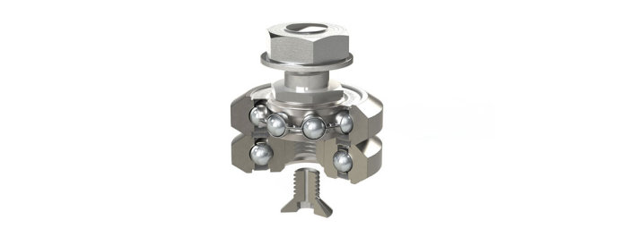Hepco 海普克 轴承 滚轮
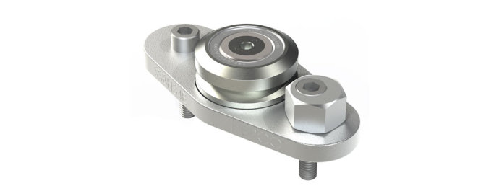Hepco 海普克 轴承 滚轮
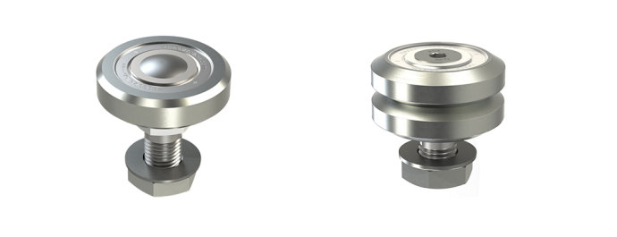Hepco 海普克 轴承 滚轮
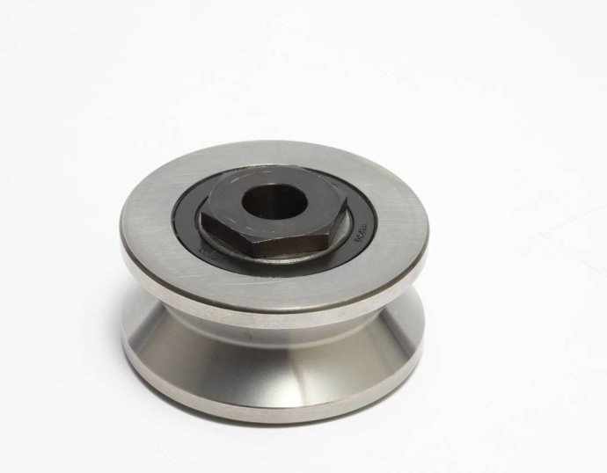Hepco 海普克 轴承 滚轮
SSRSJ13C，SSRSJ13DE，SSSJ13E
SSRSJ13CCHK，SSRSJ13DECHK，SSSJ13ECHK
SSRSJ13CDR，SSRSJ13DEDR，SSSJ13EDR
SSRSJ13CDRCHK，SSRSJ13DEDRCHK，SSSJ13EDRCHK
SSRSJ13CDRNSCHK，SSRSJ13DEDRNSCHK，SSSJ13EDRNSCHK
​
SSRSJ18C，SSRSJ18DE，SSSJ18E
SSRSJ18CCHK，SSRSJ18DECHK，SSSJ18ECHK
SSRSJ18CDR，SSRSJ18DEDR，SSSJ18EDR
SSRSJ18CDRCHK，SSRSJ18DEDRCHK，SSSJ18EDRCHK
SSRSJ18CDRNSCHK，SSRSJ18DEDRNSCHK，SSSJ18EDRNSCHK
​
SSRSJ25C，SSRSJ25DE，SSSJ25E
SSRSJ25CCHK，SSRSJ25DECHK，SSSJ25ECHK
SSRSJ25CDR，SSRSJ25DEDR，SSSJ25EDR
SSRSJ25CDRCHK，SSRSJ25DEDRCHK，SSSJ25EDRCHK
SSRSJ25CDRNSCHK，SSRSJ25DEDRNSCHK，SSSJ25EDRNSCHK
​
SSRSJ34C，SSRSJ34DE，SSSJ34E
SSRSJ34CCHK，SSRSJ34DECHK，SSSJ34ECHK
SSRSJ34CDR，SSRSJ34DEDR，SSSJ34EDR
SSRSJ34CDRCHK，SSRSJ34DEDRCHK，SSSJ34EDRCHK
SSRSJ34CDRNSCHK，SSRSJ34DEDRNSCHK，SSSJ34EDRNSCHK
​
SSRSJ54C，SSRSJ54DE，SSSJ54E
SSRSJ54CCHK，SSRSJ54DECHK，SSSJ54ECHK
SSRSJ54CDR，SSRSJ54DEDR，SSSJ54EDR
SSRSJ54CDRCHK，SSRSJ54DEDRCHK，SSSJ54EDRCHK
SSRSJ54CDRNSCHK，SSRSJ54DEDRNSCHK，SSSJ54EDRNSCHK
​
SSTHJR64CNS，SSBHJR64CNS，SSTHJR64ENS，SSBHJR64ENS
SSTHJR95CNS，SSBHJR95CNS，SSTHJR95ENS，SSBHJR95ENS
SSTHJR120CNS，SSBHJR120CNS，SSTHJR120ENS，SSBHJR120ENS
SSTHJR128CNS，SSBHJR128CNS，SSTHJR128ENS，SSBHJR128ENS
SSTHJR150CNS，SSBHJR150CNS，SSTHJR150ENS，SSBHJR150ENS

RLJ13C，RLJ13DE，LJ13E
RLJ13CCHK，RLJ13DECHK，LJ13ECHK
RLJ13CDR，RLJ13DEDR，LJ13EDR
RLJ13CDRCHK，RLJ13DEDRCHK，LJ13EDRCHK
RLJ13CDRNSCHK，RLJ13DEDRNSCHK，LJ13EDRNSCHK
​
RLJ18C，RLJ18DE，LJ18E
RLJ18CCHK，RLJ18DECHK，LJ18ECHK
RLJ18CDR，RLJ18DEDR，LJ18EDR
RLJ18CDRCHK，RLJ18DEDRCHK，LJ18EDRCHK
RLJ18CDRNSCHK，RLJ18DEDRNSCHK，LJ18EDRNSCHK

RLJ25C，RLJ25DE，LJ25E
RLJ25CCHK，RLJ25DECHK，LJ25ECHK
RLJ25CDR，RLJ25DEDR，LJ25EDR
RLJ25CDRCHK，RLJ25DEDRCHK，LJ25EDRCHK
RLJ25CDRNSCHK，RLJ25DEDRNSCHK，LJ25EDRNSCHK
RLJ34C，RLJ34DE，LJ34E
​
RLJ34CCHK，RLJ34DECHK，LJ34ECHK
RLJ34CDR，RLJ34DEDR，LJ34EDR
RLJ34CDRCHK，RLJ34DEDRCHK，LJ34EDRCHK
RLJ34CDRNSCHK，RLJ34DEDRNSCHK，LJ34EDRNSCHK

RLJ54C，RLJ54DE，LJ54E
RLJ54CCHK，RLJ54DECHK，LJ54ECHK
RLJ54CDR，RLJ54DEDR，LJ54EDR
RLJ54CDRCHK，RLJ54DEDRCHK，LJ54EDRCHK
RLJ54CDRNSCHK，RLJ54DEDRNSCHK，LJ54EDRNSCHK

